Name
Institution
Course
Date
Lobbying Heats Up Over US Ethanol
- By Mario Parker/Bloomberg News Editor. February 9, 2017.
www.renewableenergyworld.com/articles/2017/02/lobbying-heats-up-over-us-ethanol.html

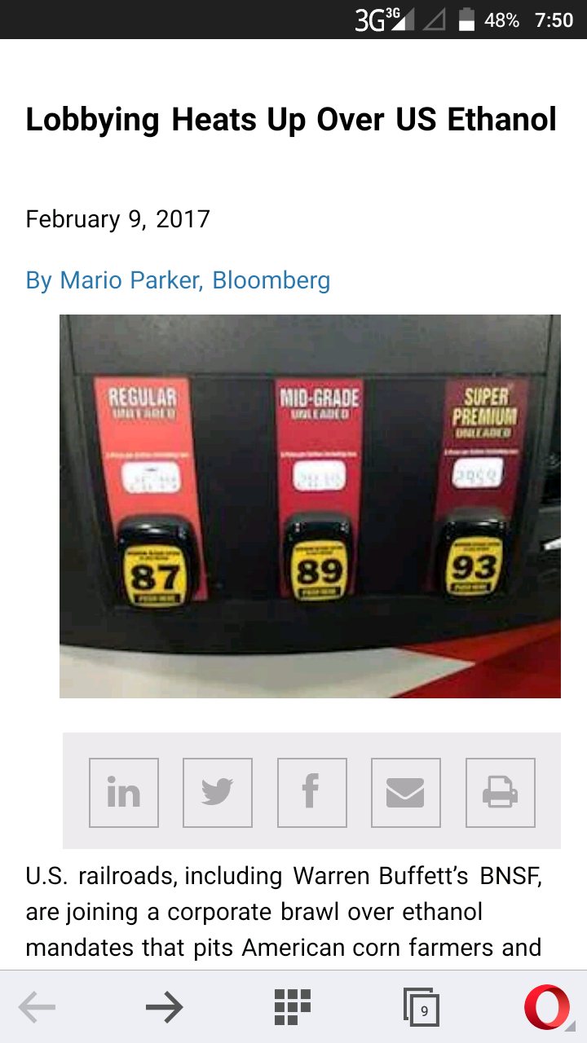
“Lobbying Heats up over US Ethanol” is an article by Mario Parker. It talks more about how the production of ethanol should be increased in the US to allow only consumption of biofuels.
Key Words: Ethanol and Biofuels
Warren Buffets is among the U.S railroads that has decided to join the race to deal with ethanol mandates which has made American corn farmers together with a number of fuel distributors to protest against oil refineries. The renewable fuel standards that works with companies such as Valero Energy Corp has been experiencing a down time due to American association of rail roads (AAR) has developed lack of interestin changing their sources of energy from non-renewable to renewable.
The author argues that George W. Bush made a huge contribution concerning the increase of production of alternative sources of fuel such as ethanol. This concern was spearheaded by his desire for US to adopt new means of producing ethanol as the main gasoline for vehicles as this would save the citizens from consuming too much oil.
He also went ahead to seek that each gallon would be investigated and ensure that it is produced following the new guidelines. These guidelines also required the mixture of biofuels like energy so that oil consumption rate goes down. In case a refiner lacks these biofuels to add to their energy, they should purchase it from the market and ensure they still produce more gasoline. This program came in with severalchallenges such as lack of ethanol for mixing with other biofuels to produce gasoline.
Some refiners did not find a chance to access ethanol or any other biofuels that they would incorporate to their normal gasoline. Also, the program continued to bring more challenges as changing the process of manufacturing gasoline itself would introduce more restrictions in the market both for the consumer and the producer. The agency involved sought to solve these challenges by creating an open platform through which one would blend in easily and in an affective manner that manufacturers would appreciate.
Early this year, environmental regulations came in to distract the process again and this was because the environmental agency did not welcome any form of environmentalpollution as a result of the production of gasoline with the presence of ethanol or other biofuels.
About Mario Parker


Mario Parker is a news editor and a journalist at Bloomberg News. The author majors in various fields such as agriculture, finance, energy and general breaking news. He is a professional with several experiences and expertise in the field of journalism. He attained a master’s degree in journalism in 2006. He also happens to have a bachelor’s degree in communication arts. His skills are vast and within his works, he has been able to portray these skills in writing articles and editing news concerning renewable fuels, energy, investigative reporting and financial reporting. In addition, the author has acquired several awards out of his great works and amongst there are “Society of American Business Editors and Writers” back in May, 2011 and “New King Coal” in November, 2010.

